**British towns that are no-go areas for white people: Muslim author's study of mosques reveals children 'attacked for being white', parents making families live under Taliban-like rules and women who can't leave home without permission**

* **Author Ed Husain visited places of worship across UK for Among the Mosques**
* **Would turn up unannounced to the largest weekly gathering, Friday prayers**
* **Spoke to taxi drivers, business owners, Imams and worshipers about religion**
* **Islam in Britain is dominated by ultra-orthodox sect promoted by the Deobandis**
* **Control over half of Britain's mosques, and gave birth to Taliban in Afghanistan**
* **One person described 'Bolton, Dewsbury and Blackburn' as 'different universe'**
* **Books for sale detail how women should be banned from leaving the house**
* **Mosque in Didsbury, in converted church, has a sign for the 'Sharia Department'**
* **White men revealed 'no-go areas' in Blackburn where they would be 'jumped'**
* **White woman in Bradford predicts it will become 'an apartheid city' in 30 years**

By [MailOnline Reporter](https://www.dailymail.co.uk/home/search.html?s=&authornamef=MailOnline+Reporter)

An author who visited mosques across Britain to investigate integration has revealed how parts of Blackburn are 'no-go areas' for white men, while ultra-orthodox parents in Bradford make children live under Taliban-like rules.

Author and political advisor Ed Husain, Professor at the Walsh School of Foreign Service in Georgetown University, has penned Among The Mosques: A Journey Across Muslim Britain in which he explores some of the UK's largest mosques and the Muslim communities worshiping there.

The Muslim writer, who was himself radicalised in his youth and trained for Jihad by the same people as Omar Khyam, leader of the Bluewater bombers, grew up in a Bangladeshi family in Tower Hamlets, East [**London**](https://www.dailymail.co.uk/news/london/index.html).

In the book, which is set to be released next week, Ed details how he researched his work by 'turning up unannounced' to the communal Friday prayers at the central mosque in cities across the country.

Husian, also chronicled conversations with taxi drivers, business owners, Imams and local white people about the mosques and the surrounding community, painting a worrying picture of divided communities - with white people in towns across the country admitting there are 'no-go areas' where they fear being physically attacked.

One man in Blackburn said 'Asian' teenagers repeatedly 'jumped' his 12-year-old son in broad daylight for 'being white'.

Areas like Bolton, Dewsbury and Black are described 'a different universe', while he observes that in parts of the cities he has visited: 'A Muslim can spend months with no contact whatsoever with mainstream 'white' Britain'.

Elsewhere, parents in Bradford Muslim parents have banned children from taking part in drama, theatre and dance classes as well as drawing, in echoes of rules implemented by the Taliban in Afghanistan and ISIS in Syria.

They are 'physically in Britain but mentally living elsewhere,' said Husain.

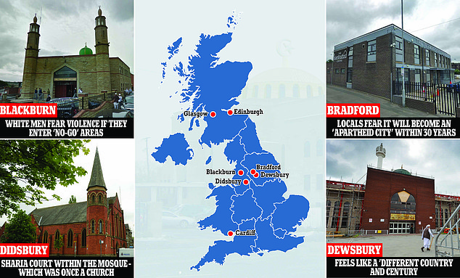

+10

Ed Husain, who visited mosques across Britain for his new book, has revealed how parts of Blackburn are 'no-go areas' for white men, while ultra-orthodox parents in Bradford make children live under Taliban-like rules

BLACKBURN: WHITE MEN FEAR VIOLENCE IF THEY ENTER 'NO-GO' AREAS

Among the areas Ed visited was Blackburn, which has the highest Muslim population outside of London, the global hub for the Deobandis and the Tablighi Jamaat.

Almost half the mosques in the UK are controlled by the Deobandis, the ultra-orthodox version of the faith, which created the Taliban in Afghanistan, while the Tablighi Jamaat espouses a return to 'true' Islam as observed by the Prophet Mohammed.

In the city, where Ed was told mosques grow 'organically', he was shocked to discover the levels of resentment between white locals and Muslim citizens.

A group of white men told him they are scared to go into 'no-go areas' in the town, such as Whalley Range, with one man saying a gang of 'Asian' teenagers repeatedly 'jumped' his 12-year-old son.

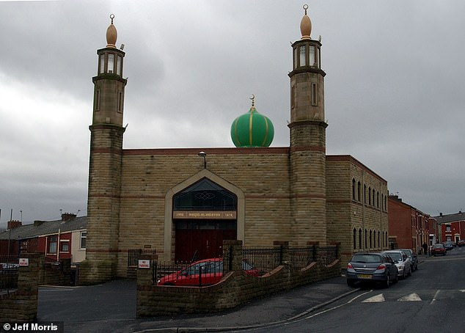

+10

Among the areas Ed visited was Blackburn, the global hub for the Deobandis and the Tableeghi Jamaat (pictured, the Masjid Al Hidayah Mosque in Blackburn)

**Whalley Range: The 'no-go area for white men'**

Two white men who were locals of Blackburn told Ed Whalley Range was a 'no-go area'.

The suburb, according to the 2011 census, is 30 per cent British Asian and 38 per cent White.

Upon visiting the area, Ed finds  the supporters of the killer of Salman Taseer, and supporters of Pakistan's blasphemy laws, advertising their propaganda.

He also saw are posters for al-Aqsa Mosque and a gathering about liberating Jerusalem from Israel.

The high street was packed with shops for arranging Hajj pilgrimages, restaurants which provide gender separation, Islamic bookshops and a number of mosques.

One man tells him: ‘My son’s been jumped fi ve times, they were all Asian. Five times.’

‘You mean Asian kids?’ I try to clarify. ‘No, Asian men!’ he says, with emphasis. ‘Eighteen- and nineteen-year-olds. My lad’s only twelve. They battered him in broad daylight here.’

‘For what?’ I ask, astonished. They don’t look happy at my questions, and they both go quiet.

‘For being white,’ he says, slowly and deliberately. ‘Wrong area!’

‘No!’ I say, unable to stop myself. ‘Yes! Yes!’ he says.

‘You get it in Blackburn, mate. You go to certain areas of Blackburn, they’re no-go areas … no-go areas,’ says the larger man.

I still can’t believe them.

 ‘Look, this is what the media guys say, but is it really true?’

‘That is true, yes. Th ere are no-go areas in Blackburn, mate, yes.’ I am shocked. How can it be ‘no-go’? ‘So what will happen?’ I ask.

 ‘If we go to Whalley Range, like, him and me at night-time, we’re guaranteed to get jumped. We won’t walk out of it. We won’t walk to the other end of the street.’

They told Ed the boy was 'battered him in broad daylight...for being white'.

Another man in the group said the area of Whalley Range, which according to the 2011 census was 30 per cent British Asian and 38 per cent White, was a particular area they would avoid.

They told him:  'If we go to Whalley Range at night-time, we're guaranteed to get jumped. We won't walk out of it. We won't walk to the other end of the street.'

They also claimed the council for Blackburn with Darwen would 'threaten you with eviction' for flying the English flag' and called it 'racist.'

Meanwhile former councillor Saima Afzal told Ed that at one Muslim school in Blackburn the headteacher had withdrawn young girls from swimming lessons, saying it was inappropriate for them to wear swimming costumes.

As well as visiting the Central Mosque, Ed visited what he described as an 'otherwise ordinary-looking shop' in which he found several books detailing strict restrictions for women.

He discovered copies of Bahishti Zewar, which insists that it is a sin to 'enjoy dancing and listening to music' and to 'like and be attracted to the customs of the kuffar [unbelievers]'.

He also uncovered Mukhtasar al-Quduri: A Manual of Islamic Law, which cites: 'When a girl reaches puberty, it is not appropriate that any of her should be seen, excepting her face, and her hands up to the wrists.'

BRADFORD: LOCALS FEAR IT WILL BECOME AN 'APARTHEID CITY' WITHIN 30 YEARS

In nearby Bradford, Ed was amazed by the lack of white English people in the city, and asked a Muslim taxi driver 'where they are'.

He was told they had all 'gone with the wind.'

According to the author, there were mosques 'on almost every corner', with Ed writing: 'Then there are houses that also serve as mosques and madrasas , banners affixed to their façades.'

Ed learned that Muslim parents living in the area had forbidden their children from taking part in drama, theatre and dance classes as well as drawing.

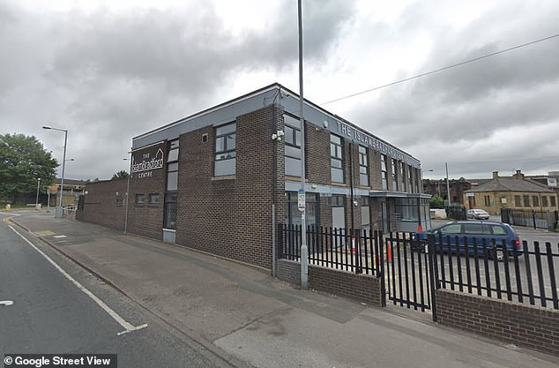

+10

Upon visiting Bradford, Ed visited The Islam Bradford Centre and heard a sermon from an Imam who commands worshipers to avoid the 'innovations of the modern world'

'Islam, as I am regularly told, prohibits figurative art and also bans dancing. So the children are not permitted to draw or dance, and their parents cannot allow them to come here,' he's told by the firector of a theatre company for children with special needs and disabilities.

He also visited The Islam Bradford Centre and heard a sermon from an Imam who commands worshipers to avoid the 'innovations of the modern world.'

Ed writes: 'All new matters, he says, are deviations, and all deviations belong in hellfire.

'He speaks from paper notes and delivers the entire sermon in English, again differing from many other mosques I have encountered where Arabic and Urdu sections are also delivered.'

Meanwhile another Imam in the city told him he was concerned about the 'widespread abuse of disabled children in the Muslim community.'

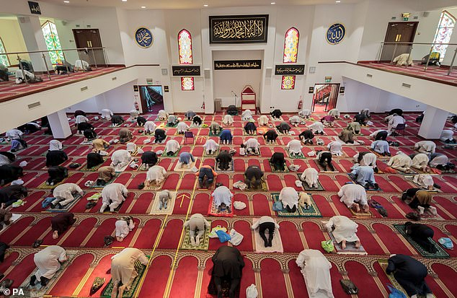

+10

According to the author, there were mosques 'on almost every corner' in Bradford (pictured, worshippers at Bradford Central Mosque)

Ed was told: '[Disabled children] are hidden away. Many of the Muslim parents just don't care about these children, and take their social benefit money and use it to support their families, open shops, back in Kashmir.'

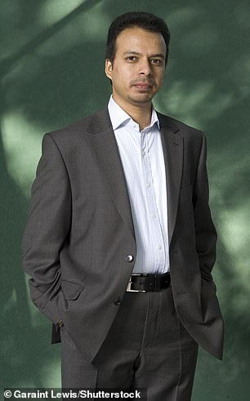

+10

Ed he also chronicled conversations with taxi drivers, business owners, Imams and local white people about the mosques (pictured)

After visiting an Islamic bookstore he discovered works glorifying violent jihad by Sayyid Qutb, the Egyptian godfather of Islamist terror and an acknowledged influence on Osama bin Laden and al-Qaeda.

He spoke to the director of a local theatre company dedicated to helping disabled children and those with special educational needs, Louise Denham, about how the communities could come together.

But she was pessimistic, and warned that Bradford could become 'an apartheid city' within 30 years.

She predicted: 'There'll be more pushback against diversity. We'll have parties like Nazi Germany organising against the immigrant and Muslim populations.'

Ed concluded that while the community was physically in Britain, they are mentally living elsewhere.

DEWSBURY: FEELS LIKE A 'DIFFERENT COUNTRY AND CENTURY WHERE WOMEN AREN'T ALLOWED OUTSIDE WITHOUT HUSBAND'S PERMISSION

Ed stated that upon arriving in Dewsbury, he feels 'as though he is in a different country and century'.

The Markazi Mosque mosque, one of the largest mosques in Europe with space for 4,000 people, is controlled by the Deobandis.

There were no spaces allocated for women to pray, with a cleric telling Ed: 'There can be no discussion of there being women in the mosque. This would be a temptation for many.'

Local bookshops sold pamphets and books promoting the separation and suppression of women, with one even outlining how women shouldn't leave the house without their husband's permission.

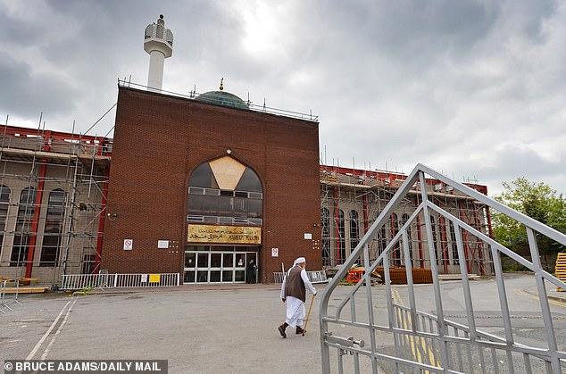

+10

Ed stated that upon arriving in Dewsbury, he feels 'as though he is in a different country and century' (pictured, the Markazi Mosque mosque, which is controlled by the Deobandis)

It read: 'When a woman leaves her home without her husband's consent then all the angels of the skies and the entire universe curse her for this act until she returns home.'

**What is the The Tablighi Jamaat movement and why does it teach opposition to British culture?**

The Tablighi movement espouses a return to 'true' Islam as observed by the Prophet Mohammed.

It's a global Islamic missionary movement with an austere, ultra-conservative religious creed nurturing the belief that British values pose a threat to Muslims.

One of Tablighi Jamaat’s leading advocates, the scholar Ebrahim Rangooni, has proclaimed that the movement’s purpose is to rescue Muslims ‘from the culture and civilisation of the Jews, the Christians and other enemies of Islam.’

He tells the faithful to ‘save your progeny from the education of the British school or college in the same way as you would save them from a lion or wolf’.

The group has been revealed in court as having links to some of the terror suspects, with several having passed through other mosques run by the group.

The organisation, which has 80 million followers worldwide, insists it is a peaceful, apolitical revivalist movement that promotes Islamic consciousness among individual Muslims.

But intelligence agencies have cautioned that its ability to radicalise young men could lead to jihadist terrorism.

Another stated: 'Being in seclusion with a strange woman, and the reckless intermingling between men and women, is most certainly haram , forbidden in the religion of God. '

And a third read: 'The woman was the strongest factor in destroying noble characteristics.'

The mosque is also the central office for the Tableeghi Jamaat, which was founded in India in 1927 to stop the dilution of Muslim identity in the cosmopolitan cities of British India.

Its founder's slogan was ' Ai Musolmano, Musolman bano! ', meaning 'O Muslims, become [real] Muslims!'

Out in the city's streets, women were out shopping with their faces covered with black veils.

Ed called it 'the culture of caliphism', explaining: 'The Tableeghi Jamaat separates itself from secular society, and preaches from door to door, to create a Muslim society from which a caliphate is expected eventually to emerge.'

Meanwhile he spoke to one elderly white  couple in a pub who said 'locals' aka the Muslim community 'don't talk to them.'

DIDSBURY: SHARIA COURT WITHIN THE MOSQUE - WHICH WAS ONCE A CHURCH

During a trip to Didsbury, he visited the town's mosque, which was a church before it was purchased in 1967 by Syrian Arabs.

He came across people hauling banners and Palestinian flags into the mosque and, once inside, found posters urging support for an aid organisation accused of links with extremists.

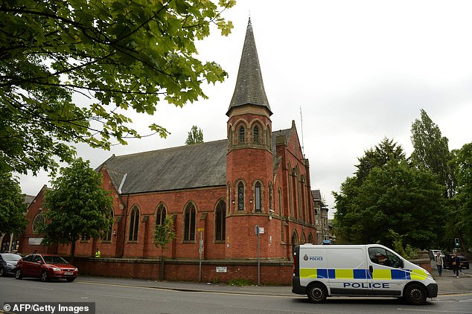

+10

Ed found a sign for a 'Sharia Department' in the Didsbury Mosque, a place of worship which was once a church

Meanwhile he also discovered a sign for the 'Sharia Department', which deals with divorces and marriages, and any disputes and other issues that Muslims want to take to sharia.

Under Islamic law, marriage is a legal bond and social contract between a man and a woman, but the marriages are not binding under UK law.

One of the books on display in the mosque was by Khurshid Ahmad, an ideologue of the Jamaat-e-Islami and other Islamist groups in Pakistan who has advocated for the creation of an Islamic state.

Ahmad has referred to members of al-Qaeda as 'brethren' and refused to acknowledge their role in the 9/11 attacks.

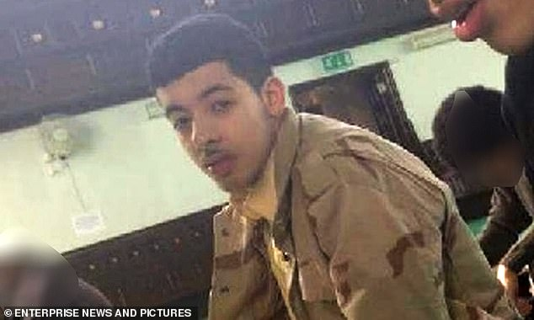

+10

Among those who have worshiped at the mosque in the past is Salman Abedi, who detonated a suicide bomb killing 22 at an Ariana Grande concert in the city

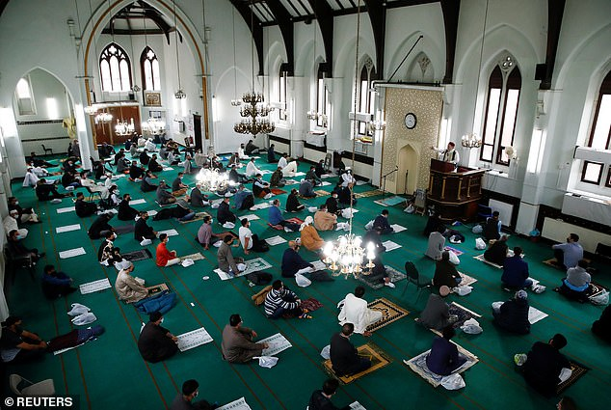

+10

The Didsbury Mosque was a church before it was purchased in 1967 by Syrian Arabs (pictured, worshipers celebrating Eid earlier this year)

Among those who have worshiped at the mosque in the past is  Salman Abedi, who detonated a suicide bomb killing 22 at an Ariana Grande concert in the city.

Abedi and his family regularly attended the mosque and his father sometimes led the call to prayer.

In the days after the attack an imam from the mosque came out an assured the public the mosque did not back the views of Abedi.

MANCHESTER: OFFICIAL FOR COUNCIL SAYS REFUGEES ARE 'TROUBLED BY PEACE' AND 'WANT TO SEEK REVENGE FOR WRONGS'

Later, Ed met with a long-time friend, Faiza, whom he had spoken to for years about issues in the Muslim community, including the decision to wear a full face veil.

**HOW CONSERVATIVE DEOBANDI SECT WHICH DESCRIBES CHRISTIANS AND JEWS AS 'REPULSIVE' HAS BECOME THE MOST POPULAR IN UK**

The Deobandi sect was founded 150 years ago in south Asia and Deobandi seminaries produce 80 per cent of UK-trained Islamic clerics.

The movement takes its name from the town of Deoband in northern India, but has spread around the world thanks to the movement of populations.

Leaders in the sect tend to promote a conservative interpretation of Islam, although they have also spoken out against violent extremism in the past.

One Deobandi scholar, Masood Azhar, drew adoring crowds on a visit to Britain in the 1990s where he urged young people to 'prepare for jihad', and is now wanted for his involvement in a deadly attack on an Indian military base.

A website promoting the Deobandi sect says loyalty is owed only to the global brotherhood of Muslims while integration into British society is denounced.

It states that to befriend a non-Muslim risks pollution while those considering marrying a Christian or Jew are warned that their ‘repulsive qualities will filter into Muslim homes’.

It adds that a woman’s place is in the home and urges Muslims to reject unIslamic acts such as music, singing, dancing, watching television, playing chess, reading novels watching drama and watching football

However she felt she was unable to meet Ed alone without a chaperone, so her husband joined them for the meeting.

She stated that one of the University of Manchester's two prayer facilities for Muslim students was dominated by a Salafi extremist preacher.

Meanwhile Ed also met with Mahfuz Alimain, a senior official at Manchester Council.

He told him refugees often struggle to adjust to life in Manchester because they are so accustomed to the violence of their own countries.

He explained: 'Syrians and Libyans, Yemenis and Palestinians who come to British mosques have seen bombs and destruction daily. Killings are normal for them.

'Peace in Manchester troubles them; they feel they need to seek revenge and justice for the wrongs done to them in their countries.'

Meanwhile Mahfuz said that in mosques, the community can see refugees are 'constantly agitated against stability at every level'.

He said that the younger generation in particular 'encourage this instability and trouble', adding: 'The elders understand the need to work with everyone, while the complaints of the younger ones then draw the attention of the war-torn Arab newcomers.'

Finishing his trip to Manchester, Ed met with two of his wife's friends for dinner.

One told him: 'In Bolton, Dewsbury, Blackburn, Preston, it's a different universe. Women don't work.

'Most of my cousins are at home looking after their husbands, who are taxi drivers or postmen. The mosques there don't allow women to pray.'

EDINBURGH: POSTERS AT MOSQUE HIGHLIGHTING GROUP ACCUSED OF ANTI-SEMITISM

At Edinburgh's Central Mosque, Ed found it was guarded by security wearing high-vis jackets.

He spotted a poster for a 'Politics and Media Masterclass', which promised to focus on who regulates the media, how to challenge it and how legislation is made.

It was sponsored by MEND (Muslim Engagement and Development), a controversial group.

The group is an NGO that aims to encourage British Muslim communities to be more involved in British media and politics.

The advocacy group also ardently opposes the government's anti-radicalisation strategy. In 2017, it was accused of 'promoting extremism'.

The founder, Mr Ismail has previously caused upset when he claimed, after MPs voted to recognise Palestine, that it was 'the first vote lost by the Israeli lobby in parliament for 300 years'.

GLASGOW: CHILDREN FORCED TO WEAR HIJABS AS UNIFORM TO 'COVER THEIR PRIVATE PARTS

The author later travelled to Glasgow to visit several mosques, including the Central Mosque, in the city.

On the wall was an advertisement for a lecture by Shaykh Ahmad Ali, a British scholar of the Deobandi movement, which agreed with the theology of not allowing people to insult the Prophet.

**What is Sharia law? Islamic legal system largely drawn from the Koran**

Essentially Islam's legal system, Sharia governs all aspects of the observant Muslim's life, and is drawn largely from the Koran- the Islamic sacred book - as well as the hadiths, which are the actions attributed to the Islamic prophet Muhammad.

As well as marriage and finances, Sharia law encompasses everyday rules around things like hygiene and dress codes. Although there are Sharia councils and tribunals operating in the UK, they are not courts of law, and their rulings are based purely on religion.

They cannot overrule regular law courts, but Muslims will often seek the assistance of a Muslim council in resolving marital or financial disputes.

Many Muslim couples do not follow Islamic ceremonies with civil marriages – a requirement generated by the 1949 Marriage Act.

Today's ruling reinforces the need for a civil ceremony to ensure couples are legally married.

Large sections of the school of thought in Pakistan have also been known to support the Taliban.

During his visit, Ed was told off and forbidden from taking photographs inside the mosque by a cleric.

On his way outside, he met a Muslim soldier, who said he would never talk about his role in the mosque because the 'community wouldn't accept it.'

Later, he visited Dawate-Islami madrasa, a mosque in another part of the city.

There, young girls were required to wear all black burkas as uniform to cover their 'private parts'.

He wrote: 'The group believe their historical mandate is to oppose any insult to the Prophet, and they use hadith, sayings attribute to Mohamed, to support this claim.

'Pakistan's blasphemy laws also support this interpretation and are often used against Ahmadis as well as Christians, with sanctions ranging in severity from fines to the death penalty.'

BIRMINGHAM: MUSLIMS 'SAY THEY ARE WAITING FOR SHARIA GOVERNMENT'

While visiting Birmingham, Ed met with two friends who had recently moved to the country from Saudi Arabia.

They told him they 'can't change their religion to suit Britain', with one, Ahmed, saying: 'I have no government. We are waiting for our government of the sharia to return again, headed by a caliph.'

Nearby highstreets are lined with shops selling hijabs for young girls and books with extreme arguments, including one which states: 'Women cannot be equal to men' and another which insists: 'The emergence of the woman from her home is like the emergence of Shaitaan [Satan] himself.'

At the Birmingham's Central Mosque, he found an advertisement for a 'sisters only' Summer Fayre at a nearby girls' school which forbid boys from over the age of 10 to attend.

**WHO IS AUTHOR ED HUSAIN THE REFORMED BRITISH MUSLIM RADICAL WHO'S SINCE MADE COUNTER-EXTREMISM HIS LIFE'S WORK?**

GROWING UP

Born on 25 December 1975, British writer Ed Husain, who was trained for Jihad by the same people as Omar Khyam, leader of the Bluewater bombers, grew up in a Bangladeshi family in Tower Hamlets, East London.

His mother was born in East Pakistan, while his father had been born in what was still British India and regretted the partition of the subcontinent after British withdrawal.

The Islam the family practised was spiritual and Husain, whose real name is Mohammed Mahbub Husain, soon began travelling the country in a bid to recite from the Koran in Arabic.

While purely spiritual at first, Husain then rebelled against his parents and found himself mixing with 'radicalised' Islamists at a different mosque - and grew a close bond with one student who had family links to the Young Muslims Organisation (YMO) and the south Asian Jamaat-e-Islami.

Husain, who attended Tower Hamlets College at the time, became president of the Student Islamic Society.

Writing in his previous book The Islamist, he claimed there he was asked to use to recruit for YMO, which was in the process of being overtaken by more radical groups, including Hizb ut-Tahrir (HuT).

STUDENT YEARS

Husain spent his student years 'radicalising' and converting most of the Muslim students on campus to his ugly and violent cause.

According to his own account he was previously linked with political Islamic organisations such as the Jamat-e-Islami, the Muslim Brotherhood and Hizb ut-Tahrir.

As reported by [**CNN**](http://edition.cnn.com/TRANSCRIPTS/0705/04/cnr.02.html), referring to his own activism, Husain once noted he 'radicalised [his] entire college [because] 'there were Muslim women walking around in veils and face covers [and] Muslim men going round putting up posters.'

+10

Born on 25 December 1975, British writer Ed Husain, who was trained for Jihad by the same people as Omar Khyam, leader of the Bluewater bombers, grew up in a Bangladeshi family in Tower Hamlets, East London. Pictured, in 2007

However, Husain eventually saw through 'Islamism' for the dangerous nonsense that his father had long taught him it was, while meeting a Muslim woman at college who he went on to marry also provided the perfect distraction.

The pair travelled in the Middle East where they witnessed the huge differences in Islamic practice between tolerant, spiritual Islam found in the likes of the tomb of St John The Baptist in Syria, where Christian nuns pray alongside Muslims, and the closed world of Saudi Arabia.

TODAY

Husain, who is now a Professor in the Walsh School of Foreign Service in Georgetown University, has a BA in history from the University of North London, and later completed an MA in Middle Eastern studies at SAOS, University of London.

In 1991, Husain joined the Labour Party and two years later, he began working for HSBC in London, where he remained for several years.

In 2002, he moved to Damascus with his wife. There, he worked for the British Council teaching English whilst studying Arabic at the University of Damascus.

After two years in Syria, the married couple moved to Jeddah so that they could be closer to the Muslim holy sites of Mecca and Medina, while Husain remained working for the British Council.

In his book The Islamist, he noted he took ‘more seriously than most other teachers’ his desire to advocate British culture.

When he returned to Britain, Husain began working as a senior advisor to former UK Prime Minister Tony Blair.

In 2007, Husain spoke to the [**New York Times**](https://www.nytimes.com/2007/06/02/world/europe/02husain.html) and confirmed his support for a liberal interpretation of Islamic jurisprudence.

He said: 'In traditional circles, Muslim women are not allowed to marry non-Muslim men...But in a pluralistic world in 2007, where non-Muslim men and Muslim women are marrying, you can't say, "You can't do that."'

In 2008, Husain co-founded the counter-extremism think tank Quilliam and later joined the Council on Foreign Relations in New York, where he was Senior Fellow in Middle Eastern Studies.

While there, his policy innovation memo resulted in the US-led development of a Geneva-based global fund to help counter terrorism.

He remained there during the height of the Arab uprisings between 2010-2015, and particularly focused on its implications for the region and foreign involvement.

Speaking on the Arab Spring, he previously said: 'The Arab world is no longer across the oceans. It is also on our streets here. Millions of American citizens are of Arab descent. Millions more are here as workers and students. What happens over there matters here.'

'Can America make these people proud and empower them against Muslim extremists by changing the American story and making us all safer? Yes, it can. It must.'

In 2014, Husain was appointed to the Freedom of Religion or Belief Advisory Group of the British Foreign and Commonwealth Office.

Three years later, he joined the Wilson Center as a Global Fellow in its Middle East Program, before becoming Senior Fellow at Civitas: Institute for the Study of Civil Society in London, where he run the 'Islam, the West, and Geopolitics' research project.

Hussain also believes that is Islam is fully compatible with Western democratic society, stating that the Quran does not teach a compulsion to faith or the murder of unbelievers.

In 2017, speaking during a [**Tony Blair Institute for Global change**](https://institute.global/policy/religion-conflict-and-geopolitics-2017), he explained: 'The lived reality of Islam as a religion of compassion, pluralism, coexistence, and peace is a far cry from how it is perceived by many in the West.'

The political advisor is also author of The Islamist (Penguin, 2007), The House of Islam: A Global History (Bloomsbury, 2018), and Among the Mosques (Bloomsbury, 2021).

**Share or comment on this article:**

**Author who visited Muslim mosques across Britain reveals 'no go areas' for white men**